Lab Code | Lab Name
CSL503 | Data Warehousing and Mining Lab
Academic Year | 2021-2022

Name of Student :
Id No.
SEM / Div
Batch :
Email Id / Mob. No.

Lab Outcome:
- Design data warehouse and perform various OLAP operations.
- Implement data mining algorithms like classification.
- Implement clustering algorithms on a given set of data sample.
- Implement Association rule mining & web mining algorithm..

Sr.No. | Title of Experiments
1 | One case study on building Data warehouse/Data Mart  Write Detailed Problem statement and design dimensional modelling (creation of star and snowflake schema)
2 | Implementation of all dimension table and fact table based on experiment 1 case study
3 | Implementation of OLAP operations: Slice, Dice, Rollup, Drilldown and Pivot based on experiment 1 case study
4 | Implementation of Bayesian algorithm
5 | Implementation of Data Discretization (any one) & Visualization (any one)
6 | Perform data Pre-processing task and demonstrate Classification, Clustering, Association algorithm on data sets using data mining tool (WEKA/R tool)
7 | Implementation of Clustering algorithm (K-means/K-medoids)
8 | Implementation of any one Hierarchical Clustering method
9 | Implementation of Association Rule Mining algorithm (Apriori)
10 | Implementation of Page rank/HITS algorithm

Experiment No. 1
Title: One case study on building Data warehouse/Data Mart
Write Detailed Problem statement and design dimensional modelling (creation of star and snowflake schema)
Example : All Electronics may create a sales data warehouse in order to keep records of the store’s sales with respect to the dimensions time,item,branch and location. These dimensions allow the store to keep track of things like monthly sales of items and the branches and locations at which the items were sold.

Theory :
Data Cube : A data cube allows data to be modeled and viewed in multiple dimensions. It is
defined by dimensions and facts .
Dimensions : Dimensions are the perspectives or entities with respect to which an organization
wants to keep records.
Dimension Table : Each dimension may have a table associated withit, called a dimension table,
which further describes the dimension. For example,a dimension table for item may contain the
attributes item name, brand, and type. Dimension tables can be specified by users or experts.
Fact Table : A multidimensional data model is typically organized around a central theme, like
sales, for instance. This theme is represented by a fact table. Facts are numerical measures. fact table contains the names of the facts, or measures, as well as keys to each of the related dimension tables.

Dimensions : AllElectronics may create a sales data warehouse in order to keep records of the store’s sales with respect to the dimensions time, item, branch, and location. Each dimension may have a table associated with it, called a dimension table. Dimension table will have their own attributes. for example, a dimension table for item may contain the attributes item name, brand, and type.
Facts : Facts for a sales data warehouse include dollars sold (sales amount in dollars), units sold
(number of units sold), and amount budgeted. The fact table contains the names of the facts, or measures, as well as keys to each of the related dimension tables.

Star schema: The most common modeling paradigm is the star schema, in which the data warehouse contains (1) a large central table (fact table) containing the bulk of the data, with no
redundancy, and (2) a set of smaller attendant tables (dimension tables), one for each dimension.
The schema graph resembles a starburst, with the dimension tables displayed in a radial pattern
around the central fact table. A star schema for AllElectronics sales is shown in Figure Sales are considered along four dimensions, namely, time, item, branch, and location. The schema contains a central fact table for sales that contains keys to each of the four dimensions, along with two measures: dollars sold and units sold.

Snowflakes Schema: A snowflake schema for AllElectronics sales is given, the sales fact table is identical to that of the star schema. The main difference between the two schemas is in the

definition of dimension tables. The single dimension table for item in the star schema is normalized in the snowflake schema, resulting in new item and supplier tables. For example, the item dimension table now contains the attributes item key, item name, brand, type, and supplier key, where supplier key is linked to the supplier dimension table, containing supplier key and supplier type information. Similarly, the single dimension table for location in the star schema can be normalized into two new tables: location and city. The city key in the new location table links to the city dimension.

Experiment No. 2

Title : Implementation of all dimension table and fact table based on experiment 1 case study

- Product
CREATE table Product_dw
( prod_id int PRIMARY KEY,
Prod_name varchar(60) NOT NULL, Prod_category varchar(255) NOT NULL, Brand_name varchar(255) NOT NULL, Suppl_name varchar(255) NOT NULL, Prod_price NUMBER );

- Time
CREATE table Time_dw
(time_id int PRIMARY KEY, day DATE NOT NULL,
month varchar(255) NOT NULL,
qt varchar(255) NOT NULL,
yr varchar(255) NOT NULL);

- Location
CREATE table Location_dw
(loc_id int PRIMARY KEY, street varchar(60) NOT NULL,
city varchar(255) NOT NULL,
state varchar(255) NOT NULL, country varchar(255) NOT NULL
);

- Fact_sales
CREATE table Fact_sales
( prod_id int REFERENCES Product_dw(prod_id),
time_id intREFERENCES Time_dw(time_id),
loc_id int REFERENCES Location_dw(loc_id),
number_of_unit_sold int NOT NULL,
Total_sales int NOT NULL
);

- Product table data insert
INSERT INTO Product_dw(prod_id,Prod_name,Prod_category,Brand_name, Suppl_name,Prod_price)
VALUES (1, ‘Rice’, ‘Grocery’, 'Dawat',’Ramesh’,140 );
INSERT INTO Product_dw (prod_id,Prod_name,Prod_category,Brand_name, Suppl_name, Prod_price)
VALUES (2, ‘Sugar’, ‘Grocery’, 'Dawat',’Ramesh’,50 );
INSERT INTO Product_dw (prod_id,Prod_name,Prod_category,Brand_name, Suppl_name, Prod_price)
VALUES (3, ‘Kurta’, ‘Cloth’, 'Max',’Lila’,500 );
INSERT INTO Product_dw (prod_id,Prod_name,Prod_category,Brand_name, Suppl_name,Prod_price)
VALUES (4, ‘jacket’, ‘Cloth’, 'Max',’Lila’,700 );

- Time table data insert
INSERT INTO Time_dw(time_id,day, month,qt,yr)
VALUES (101,DATE '2021-1-17', 'january', 'Q1','2021');
INSERT INTO Time_dw(time_id, day,month,qt,yr)
VALUES (102, DATE '2021-2-14', 'february', 'Q1','2021');
INSERT INTO Time_dw(time_id, day,month,qt,yr)
VALUES (103, DATE '2021-5-21', 'may', 'Q2','2021');
INSERT INTO Time_dw (time_id, day, month,qt,yr)
VALUES (104, DATE '2021-6-26', 'june', 'Q2','2021');

- Location table data insert
INSERT INTO Location_dw(loc_id,street,city,state,country)
VALUES (201,'ML ROAD','MUMBAI','MAHARASHTRA','INDIA');
INSERT INTO Location_dw(loc_id,street,city,state,country)
VALUES (202,'AI ROAD','MUMBAI','MAHARASHTRA','INDIA');
INSERT INTO Location_dw(loc_id,street,city,state,country)
VALUES (203,'BI ROAD','KOLKATA','WEST BENGAL','INDIA');
INSERT INTO Location_dw(loc_id,street,city,state,country)
VALUES (204,'DB ROAD','KOLKATA','WEST BENGAL','INDIA');

- Fact table data insert
INSERT INTO Fact_sales(prod_id,time_id,loc_id,number_of_unit_sold,Total_sales)
VALUES (1,101,201,400,80000);
INSERT INTO Fact_sales(prod_id,time_id,loc_id,number_of_unit_sold,Total_sales)
VALUES (1,102,201,400,90000);
INSERT INTO Fact_sales(prod_id,time_id,loc_id,number_of_unit_sold,Total_sales)
VALUES (1,103,201,400,70000);
INSERT INTO Fact_sales(prod_id,time_id,loc_id,number_of_unit_sold,Total_sales)
VALUES (1,104,201,400,90000);

Experiment No. 3

Title : Implementation of OLAP operations: Slice, Dice, Rollup, Drilldown and Pivot based on experiment 1 case study

Theory : In the multidimensional model, data are organized into multiple dimensions, and each dimension contains multiple levels of abstraction. This provides users with the flexibility to view data from different perspectives.

1. Roll-up : The roll-up operation also called the drill-up operation performs aggregation on a
data cube, either by climbing up a concept hierarchy for a dimension or by dimension reduction.

2. Drill-down : Drill-down is the reverse of roll-up. It navigates from less detailed data to more detailed data. Drill-down can be realized by either stepping down a concept hierarchy for a dimension or introducing additional dimensions.

3. Slice and dice : The slice operation performs a selection on one dimension of the given cube, resulting in a subcube.

The dice operation defines a subcube by performing a selection on two or more dimensions.

4. Pivot (rotate) : Pivot (also called rotate) is a visualization operation that rotates the data axes in view in order to provide an alternative presentation of the data.

- Slice Operation
SELECT Prod_name ,Total_sales
FROM Fact_sales
INNER JOIN Product_dw
ON Fact_sales.prod_id =Product_dw.prod_id WHERE prod_name='Rice';

- Dice Operation
Select Prod_name ,Fact_sales.total_sales from((Product_dw INNER JOIN Fact_sales ON Product_dw.prod_id=Fact_sales.prod_id) JOIN Time_dw ON Fact_sales.time_id=Time_dw.time_id) where Prod_name='Rice' and qt='Q1';

- Roll up Operation
SELECT yr, SUM(total_sales) FROM (Fact_sales NATURAL JOIN Product_dw)JOIN Time_dw ON Fact_sales.time_id=Time_dw.time_id WHERE Prod_name='Rice' GROUP BY yr;

- Drill down Operation
SELECT qt,SUM(total_sales) FROM (Fact_sales NATURAL JOIN Product_dw)JOIN Time_dw ON Fact_sales.time_id=Time_dw.time_id WHERE Prod_name='Rice' GROUP BY qt;

- Pivot Operation
SELECT YR, [January], [February], [May], [June]
FROM (Select YR, MONTH, QT
FROM Time_dw as source_table PIVOT
(Max(Value) For
MONTH in ([January], [February], [May], [June])
) as PIVOT_TABLE

Experiment No. 4

Title: Implementation of Bayesian algorithm

from csv import reader
from random import seed
from random import randrange
from math import sqrt
from math import exp
from math import pi

def load_csv(filename):
dataset = list()
with open(filename, 'r') as file:
csv_reader = reader(file)
for row in csv_reader:
if not row:
continue
dataset.append(row)
return dataset

def str_column_to_float(dataset, column):
for row in dataset:
row[column] = float(row[column].strip())

def str_column_to_int(dataset, column):
class_values = [row[column] for row in dataset]
unique = set(class_values)
lookup = dict()
for i, value in enumerate(unique):
lookup[value] = i
for row in dataset:
row[column] = lookup[row[column]]
return lookup

def cross_validation_split(dataset, n_folds):
dataset_split = list()
dataset_copy = list(dataset)
fold_size = int(len(dataset) / n_folds)
for _ in range(n_folds):
fold = list()
while len(fold) < fold_size:
index = randrange(len(dataset_copy))
fold.append(dataset_copy.pop(index))
dataset_split.append(fold)
return dataset_split

def accuracy_metric(actual, predicted):
correct = 0
for i in range(len(actual)):
if actual[i] == predicted[i]:
correct += 1
return correct / float(len(actual)) * 100.0

def evaluate_algorithm(dataset, algorithm, n_folds, *args):
folds = cross_validation_split(dataset, n_folds)
scores = list()
for fold in folds:
train_set = list(folds)
train_set.remove(fold)
train_set = sum(train_set, [])
test_set = list()
for row in fold:
row_copy = list(row)
test_set.append(row_copy)
row_copy[-1] = None
predicted = algorithm(train_set, test_set, *args)
actual = [row[-1] for row in fold]
accuracy = accuracy_metric(actual, predicted)
scores.append(accuracy)
return scores

def separate_by_class(dataset):
separated = dict()
for i in range(len(dataset)):
vector = dataset[i]
class_value = vector[-1]
if (class_value not in separated):
separated[class_value] = list()
separated[class_value].append(vector)
return separated

def mean(numbers):
return sum(numbers)/float(len(numbers))

def stdev(numbers):
avg = mean(numbers)
variance = sum([(x-avg)**2 for x in numbers]) / float(len(numbers)-1)
return sqrt(variance)

def summarize_dataset(dataset):
summaries = [(mean(column), stdev(column), len(column)) for column in zip(*dataset)]
del(summaries[-1])
return summaries

def summarize_by_class(dataset):
separated = separate_by_class(dataset)
summaries = dict()
for class_value, rows in separated.items():
summaries[class_value] = summarize_dataset(rows)
return summaries

def calculate_probability(x, mean, stdev):
exponent = exp(-((x-mean)**2 / (2 * stdev**2 )))
return (1 / (sqrt(2 * pi) * stdev)) * exponent

def calculate_class_probabilities(summaries, row):
total_rows = sum([summaries[label][0][2] for label in summaries])
probabilities = dict()
for class_value, class_summaries in summaries.items():
probabilities[class_value] = summaries[class_value][0][2]/float(total_rows)
for i in range(len(class_summaries)):
mean, stdev, _ = class_summaries[i]
probabilities[class_value] *= calculate_probability(row[i], mean, stdev)
return probabilities

def predict(summaries, row):
probabilities = calculate_class_probabilities(summaries, row)
best_label, best_prob = None, -1
for class_value, probability in probabilities.items():
if best_label is None or probability > best_prob:
best_prob = probability
best_label = class_value
return best_label

def naive_bayes(train, test):
summarize = summarize_by_class(train)
predictions = list()
for row in test:
output = predict(summarize, row)
predictions.append(output)
return(predictions)

seed(1)
filename = 'iris.csv'
dataset = load_csv(filename)
for i in range(len(dataset[0])-1):
str_column_to_float(dataset, i)
str_column_to_int(dataset, len(dataset[0])-1)
n_folds = 5
scores = evaluate_algorithm(dataset, naive_bayes, n_folds)
print('Scores: %s' % scores)
print('Mean Accuracy: %.3f%%' % (sum(scores)/float(len(scores))))

#Output

Scores: [93.33333333333333, 96.66666666666667, 100.0, 93.33333333333333, 93.33333333333333]
Mean Accuracy: 95.333%

Experiment No. 5

Title : Implementation of Data Discretization (any one) & Visualization (any one).

# Implementation of Binning by means technique
import numpy as np
from sklearn.linear_model import LinearRegression
from sklearn import linear_model
# import statsmodels.api as sm
import statistics
import math
from collections import OrderedDict

x =[]
print("enter the data")
x = list(map(float, input().split()))

print("enter the number of bins")
bi = int(input())

X_dict = OrderedDict()
x_old ={}
x_new ={}

for i in range(len(x)):
X_dict[i]= x[i]
x_old[i]= x[i]

x_dict = sorted(X_dict.items(), key = lambda x: x[1])

binn =[]

avrg = 0
i = 0
k = 0
num_of_data_in_each_bin = int(math.ceil(len(x)/bi))

for g, h in X_dict.items():
if(i<num_of_data_in_each_bin):
avrg = avrg + h
i = i + 1
elif(i == num_of_data_in_each_bin):
k = k + 1
i = 0
binn.append(round(avrg / num_of_data_in_each_bin, 3))
avrg = 0
avrg = avrg + h
i = i + 1
rem = len(x)% bi
if(rem == 0):
binn.append(round(avrg / num_of_data_in_each_bin, 3))
else:
binn.append(round(avrg / rem, 3))

# store the new value of each data
i = 0
j = 0
for g, h in X_dict.items():
if(i<num_of_data_in_each_bin):
x_new[g]= binn[j]
i = i + 1
else:
i = 0
j = j + 1
x_new[g]= binn[j]
i = i + 1
print("number of data in each bin")

print(math.ceil(len(x)/bi))

for i in range(0, len(x)):
print('index {2} old value {0} new value {1}'.format(x_old[i], x_new[i], i))

# Output

enter the data
10 5 9 8 3 2 14 20 33 19 20
enter the number of bins
3
number of data in each bin
4
index 0 old value 10.0 new value 8.0
index 1 old value 5.0 new value 8.0
index 2 old value 9.0 new value 8.0
index 3 old value 8.0 new value 8.0
index 4 old value 3.0 new value 9.75
index 5 old value 2.0 new value 9.75
index 6 old value 14.0 new value 9.75
index 7 old value 20.0 new value 9.75
index 8 old value 33.0 new value 36.0
index 9 old value 19.0 new value 36.0
index 10 old value 20.0 new value 36.0

# Implementation of Visualization technique ( BoxPlot )

import matplotlib.pyplot as plt
import numpy as np

np.random.seed(10)

data_1 = np.random.normal(100, 10, 200)
data_2 = np.random.normal(90, 20, 200)
data_3 = np.random.normal(80, 30, 200)
data_4 = np.random.normal(70, 40, 200)
data = [data_1, data_2, data_3, data_4]

fig = plt.figure(figsize =(10, 7))

ax = fig.add_axes([0, 0, 1, 1])

bp = ax.boxplot(data)

plt.show()

# Output

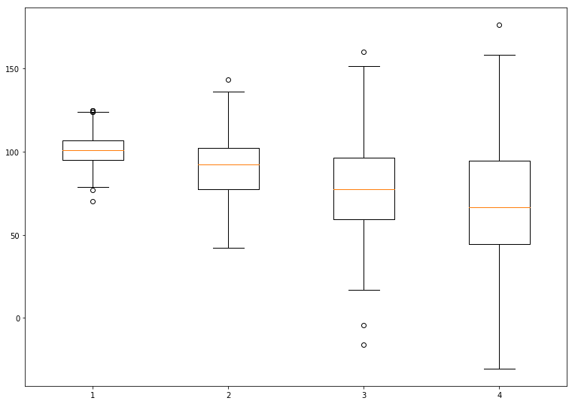

Experiment No. 6

Title : Perform data Pre-processing task and demonstrate Classification, Clustering, Association algorithm on data sets using data mining tool (WEKA/R tool)

# Dataset : Diabetes patient dataset with 769 tuples (load Diabetes.csv file or any .arff file)
- Preprocessing
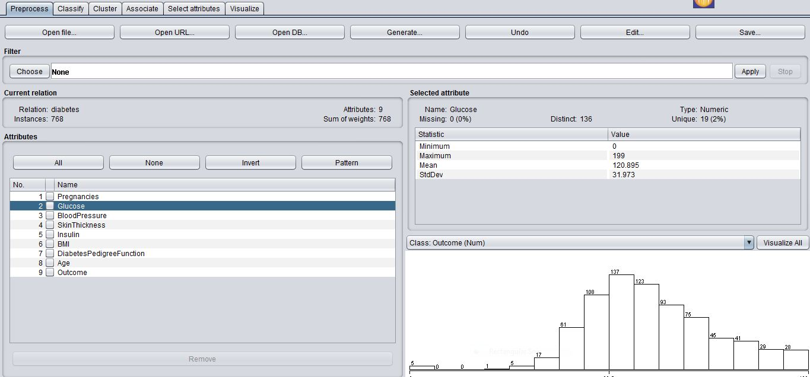
Figure : Data load for preprocessing

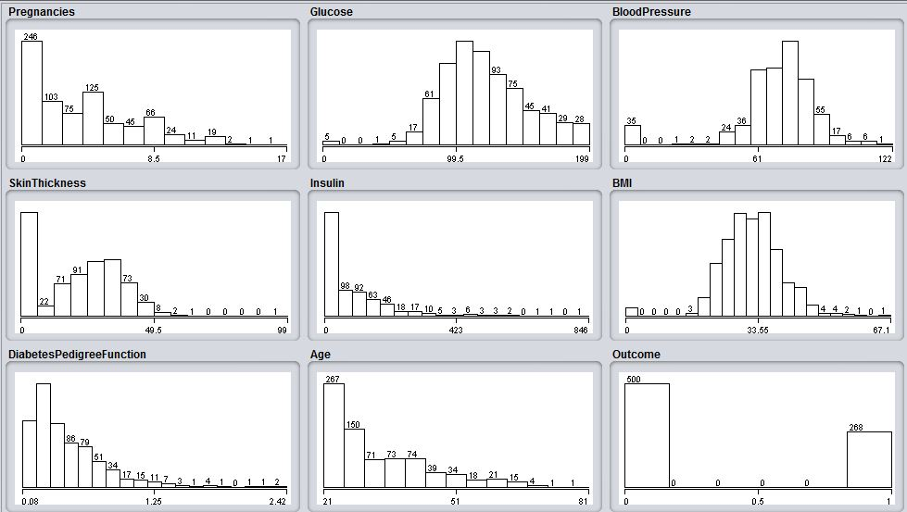
Figure: Data visualizing
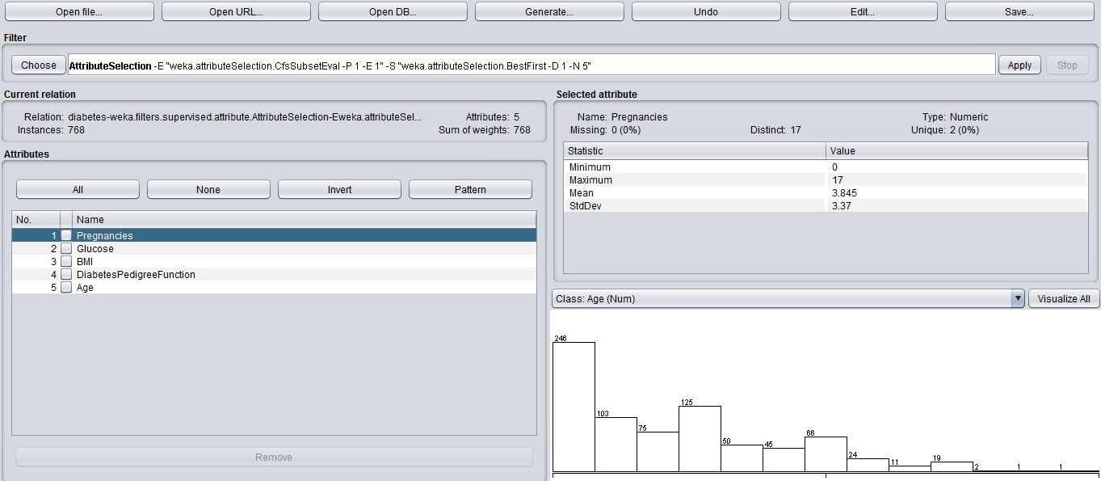
Figure: Attribute selection filter
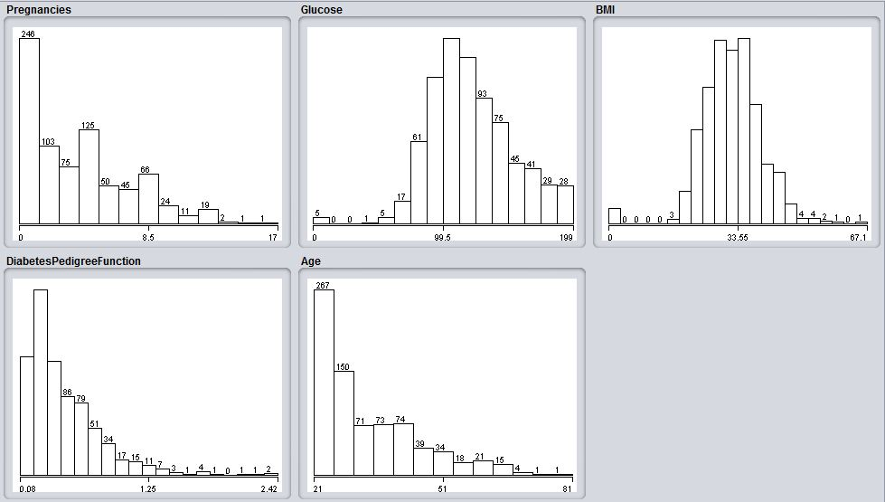
Figure: Data visualizing after preprocessing
- Classification
Attributes: 5
Pregnancies
Glucose
BMI
DiabetesPedigreeFunction
Age
Test mode: 10-fold cross-validation
=== Classifier model (full training set) ===
REPTree
============

Pregnancies < 4.5
| Glucose < 131.5
| | DiabetesPedigreeFunction < 0.73
| | | Pregnancies < 2.5
| | | | Glucose < 101.5
| | | | | DiabetesPedigreeFunction < 0.65
| | | | | | BMI < 34.85
| | | | | | | DiabetesPedigreeFunction < 0.33
| | | | | | | | DiabetesPedigreeFunction < 0.29 : 23.54 (29/3.24) [6/64.99]
| | | | | | | | DiabetesPedigreeFunction >= 0.29 : 21.71 (6/0.56) [1/0.11]
| | | | | | | DiabetesPedigreeFunction >= 0.33 : 24.31 (22/8.26) [14/31.53]
| | | | | | BMI >= 34.85 : 25.84 (18/24.24) [7/66.31]
| | | | | DiabetesPedigreeFunction >= 0.65 : 26.83 (6/19.81) [0/0]
| | | | Glucose >= 101.5 : 26.34 (76/35.22) [34/77.34]
| | | Pregnancies >= 2.5 : 28.28 (51/35.06) [31/48.62]
| | DiabetesPedigreeFunction >= 0.73 : 31.28 (32/135.88) [25/121.21]
| Glucose >= 131.5 : 32.16 (94/128.75) [40/205.81]
Pregnancies >= 4.5
| Glucose < 124.5
| | Pregnancies < 7.5 : 35.7 (50/87.96) [33/77.39]
| | Pregnancies >= 7.5 : 43.6 (42/85.63) [20/100.11]
| Glucose >= 124.5 : 45.02 (86/119.96) [45/76.47]

Size of the tree : 23

Time taken to build model: 0.19 seconds

=== Cross-validation ===
=== Summary ===

Correlation coefficient 0.5749
Mean absolute error 6.7839
Root mean squared error 9.639
Relative absolute error 70.6912 %
Root relative squared error 81.9256 %
Total Number of Instances 768

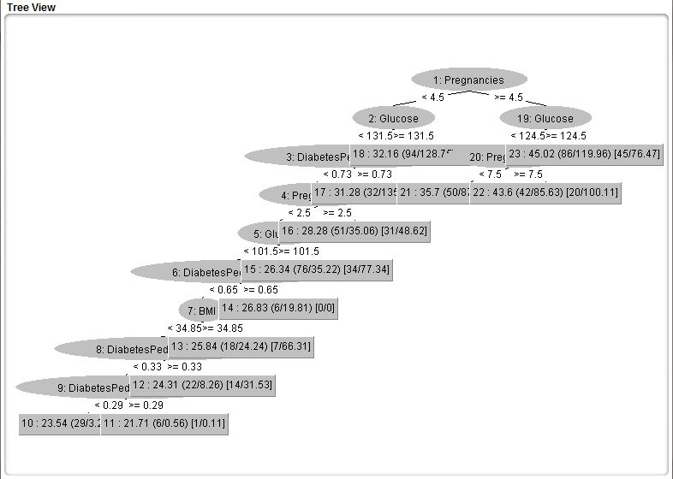
Figure: Decision Tree
- Clustering
K-means Clustering Algorithm
=== Run information ===

Scheme: weka.clusterers.SimpleKMeans -init 0 -max-candidates 100 -periodic-pruning 10000 -min-density 2.0 -t1 -1.25 -t2 -1.0 -N 2 -A "weka.core.EuclideanDistance -R first-last" -I 500 -num-slots 1 -S 10
Relation: diabetes-weka.filters.supervised.attribute.AttributeSelection-Eweka.attributeSelection.CfsSubsetEval -P 1 -E 1-Sweka.attributeSelection.BestFirst -D 1 -N 5-weka.filters.unsupervised.attribute.Remove-R6
Instances: 768
Attributes: 5
Pregnancies
Glucose
BMI
DiabetesPedigreeFunction
Age
Test mode: evaluate on training data

=== Clustering model (full training set) ===

kMeans
======

Number of iterations: 5
Within cluster sum of squared errors: 68.94505620802808

Initial starting points (random):

Cluster 0: 1,126,28.7,0.801,21
Cluster 1: 8,95,36.8,0.485,57

Missing values globally replaced with mean/mode

Final cluster centroids:
Cluster#
Attribute Full Data 0 1
(768.0) (513.0) (255.0)
===========================================================
Pregnancies 3.8451 2.0526 7.451
Glucose 120.8945 115.23 132.2902
BMI 31.9926 31.8064 32.3671
DiabetesPedigreeFunction 0.4719 0.4676 0.4805
Age 33.2409 26.7739 46.251

Time taken to build model (full training data) : 0.14 seconds

=== Model and evaluation on training set ===

Clustered Instances

0 513 ( 67%)
- 255 ( 33%)

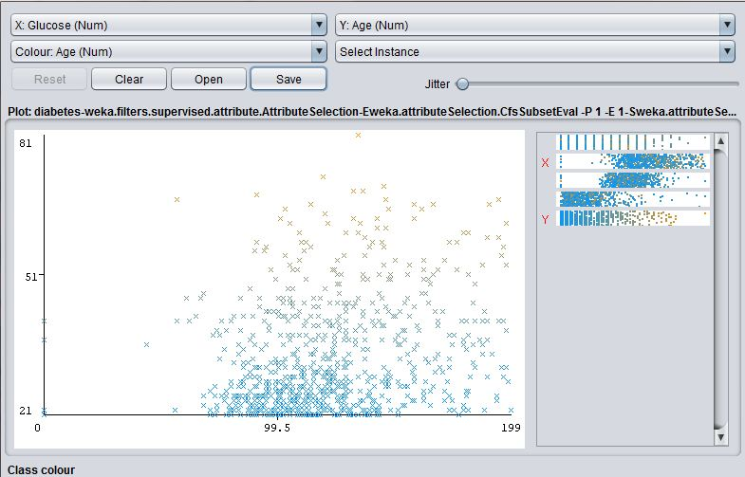
Figure: Cluster for attribute Glucose

Experiment No. 7

Title : Implementation of Clustering algorithm (K-means/K-medoids).

import pandas as pd
import numpy as np
import matplotlib.pyplot as plt

df = pd.DataFrame({
'x': [12, 20, 28, 18, 29, 33, 24, 45, 45, 52, 51, 52, 55, 53, 55, 61, 64, 69, 72],
'y': [39, 36, 30, 52, 54, 46, 55, 59, 63, 70, 66, 63, 58, 23, 14, 8, 19, 7, 24]
})
np.random.seed(200)
k = 3
# centroids[i] = [x, y]
centroids = {
i+1: [np.random.randint(0, 80), np.random.randint(0, 80)]
for i in range(k)
}
fig = plt.figure(figsize=(5, 5))
plt.scatter(df['x'], df['y'], color='k')
colmap = {1: 'r', 2: 'g', 3: 'b'}
for i in centroids.keys():
plt.scatter(*centroids[i], color=colmap[i])
plt.xlim(0, 80)
plt.ylim(0, 80)
plt.show()
def assignment(df, centroids):
for i in centroids.keys():
# sqrt((x1 - x2)^2 - (y1 - y2)^2)
df['distance_from_{}'.format(i)] = (
np.sqrt(
(df['x'] - centroids[i][0]) ** 2
+ (df['y'] - centroids[i][1]) ** 2
)
)
centroid_distance_cols = ['distance_from_{}'.format(i) for i in centroids.keys()]
df['closest'] = df.loc[:, centroid_distance_cols].idxmin(axis=1)
df['closest'] = df['closest'].map(lambda x: int(x.lstrip('distance_from_')))
df['color'] = df['closest'].map(lambda x: colmap[x])
return df
df = assignment(df, centroids)
print(df.head())
fig = plt.figure(figsize=(5, 5))
plt.scatter(df['x'], df['y'], color=df['color'], alpha=0.5, edgecolor='k')
for i in centroids.keys():
plt.scatter(*centroids[i], color=colmap[i])
plt.xlim(0, 80)
plt.ylim(0, 80)
plt.show()

import copy
old_centroids = copy.deepcopy(centroids)
def update(k):
for i in centroids.keys():
centroids[i][0] = np.mean(df[df['closest'] == i]['x'])
centroids[i][1] = np.mean(df[df['closest'] == i]['y'])
return k

centroids = update(centroids)
fig = plt.figure(figsize=(5, 5))
ax = plt.axes()
plt.scatter(df['x'], df['y'], color=df['color'], alpha=0.5, edgecolor='k')
for i in centroids.keys():
plt.scatter(*centroids[i], color=colmap[i])
plt.xlim(0, 80)
plt.ylim(0, 80)
for i in old_centroids.keys():
old_x = old_centroids[i][0]
old_y = old_centroids[i][1]
dx = (centroids[i][0] - old_centroids[i][0]) * 0.75
dy = (centroids[i][1] - old_centroids[i][1]) * 0.75
ax.arrow(old_x, old_y, dx, dy, head_width=2, head_length=3, fc=colmap[i], ec=colmap[i])
plt.show()

df = assignment(df, centroids)
fig = plt.figure(figsize=(5, 5))
plt.scatter(df['x'], df['y'], color=df['color'], alpha=0.5, edgecolor='k')
for i in centroids.keys():
plt.scatter(*centroids[i], color=colmap[i])
plt.xlim(0, 80)
plt.ylim(0, 80)
plt.show()
while True:
closest_centroids = df['closest'].copy(deep=True)
centroids = update(centroids)
df = assignment(df, centroids)
if closest_centroids.equals(df['closest']):
break
fig = plt.figure(figsize=(5, 5))
plt.scatter(df['x'], df['y'], color=df['color'], alpha=0.5, edgecolor='k')
for i in centroids.keys():
plt.scatter(*centroids[i], color=colmap[i])
plt.xlim(0, 80)
plt.ylim(0, 80)
plt.show()

##Output
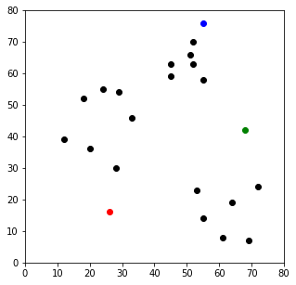
x y distance_from_1 distance_from_2 distance_from_3 closest color
0 12 39 26.925824 56.080300 56.727418 1 r
1 20 36 20.880613 48.373546 53.150729 1 r
2 28 30 14.142136 41.761226 53.338541 1 r
3 18 52 36.878178 50.990195 44.102154 1 r
4 29 54 38.118237 40.804412 34.058773 3 b

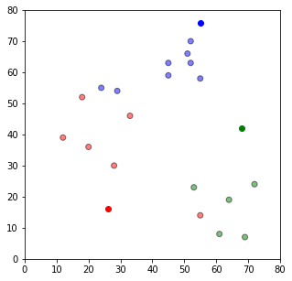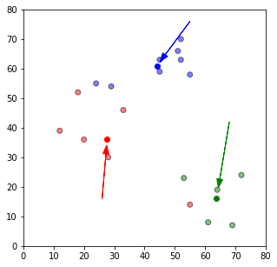

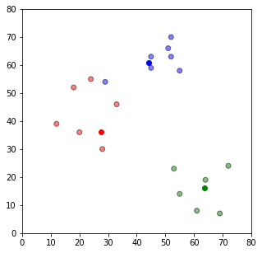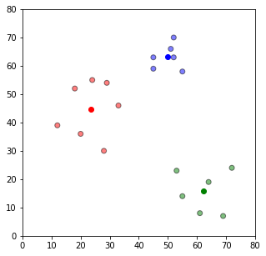

Experiment No. 8

Title : Implementation of Association Rule Mining algorithm (Apriori)

import numpy as np
import matplotlib.pyplot as plt
import pandas as pd

dataset = pd.read_csv('store_data.csv', header = None)
transactions = []
for i in range(0,7501):
transactions.append([str(dataset.values[i,j]) for j in range(0,20)])

from apyori import apriori

rules= apriori(transactions,
min_support = 0.003,
min_confidence = 0.2,
min_lift = 3,
min_length = 2)

MB = list(rules)

Result = [list(MB[i][0]) for i in range(0,len(MB))]

for item in Result:

pair = item[0]
items = [x for x in pair]
print("Rule: " + item[0] + " -> " + item[1])

print("Support: " + str(item[1]))

print("Confidence: " + str(item[1][2][0]))
print("Lift: " + str(item[1][2][0]))
print("=====================================")

#Sample Output

=====================================
Rule: shrimp -> pasta
Support: pasta
Confidence: s
Lift: s
=====================================
Rule: olive oil -> spaghetti
Support: spaghetti
Confidence: a
Lift: a
=====================================
Rule: whole wheat rice -> spaghetti
Support: spaghetti
Confidence: a
Lift: a
=====================================
Rule: milk -> avocado
Support: avocado
Confidence: o
Lift: o
=====================================
Rule: milk -> cake
Support: cake
Confidence: k
Lift: k

Experiment No. 9

Title : Implementation of Page rank/HITS algorithm.

# Implementation of Page Rank Algorithm
# Tools used : Anaconda 3 jupyter

import numpy as np
from scipy.sparse import csc_matrix

def pageRank(G, s = .85, maxerr = .0001):

n = G.shape[0]

A = csc_matrix(G,dtype=np.float)
rsums = np.array(A.sum(1))[:,0]
ri, ci = A.nonzero()
A.data /= rsums[ri]

sink = rsums==0

ro, r = np.zeros(n), np.ones(n)
while np.sum(np.abs(r-ro)) > maxerr:
ro = r.copy()

for i in range(0,n):

Ai = np.array(A[:,i].todense())[:,0]

Di = sink / float(n)

Ei = np.ones(n) / float(n)

r[i] = ro.dot( Ai*s + Di*s + Ei*(1-s) )

return r/float(sum(r))

if __name__=='__main__':

G = np.array([[0,0,1,0,0,0,0],
[0,1,1,0,0,0,0],
[1,0,1,1,0,0,0],
[0,0,0,1,1,0,0],
[0,0,0,0,0,0,1],
[0,0,0,0,0,1,1],
[0,0,0,1,1,0,1]])
print(pageRank(G,s=.86))

#Output
Ranks of each Connected Page
[0.12727557 0.03616954 0.12221594 0.22608452 0.28934412 0.03616954
0.16274076]

